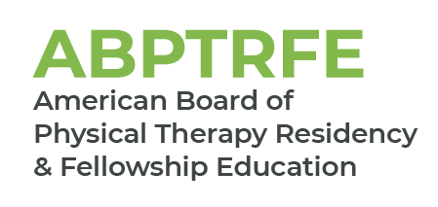
Medical Conditions – Neurology
For Renewal of Accreditation and ACIR

Please complete the chart below by filling in the medical conditions seen by the resident over the course of the program. Patients evaluated, treated, or managed by the resident as part of the resident’s education throughout the course of the program should be included within the template.

The patient’s medical condition is only counted during the first patient encounter. Patient encounters beyond the initial visit should not be included in the frequency count.
Name of Graduate:
Medical Conditions  Neurology | Number of Patients Evaluated, Treated, or Managed by the Resident as Part of the Program’s Curriculum
Nervous System
Acute poliomyelitis and postpoliomyelitis syndrome
Amyotrophic lateral sclerosis (ALS)
Basal ganglia disorders (eg, Parkinson disease, Huntington disease, dystonias)
Central nervous system tumors
Cerebellar disorders
Cerebral palsy
Cerebrovascular disease
Dementia/Alzheimer’s disease
Guillain-Barre syndrome and polyneuropathies
Multiple sclerosis
Peripheral neuropathy
Psychiatric disorders and aphysiologic disorders
Spinal cord injury
Traumatic brain injury
Vestibular disorders
Musculoskeletal System
Muscle disease
Involvement Of Multiple Systems
Amputations in individuals with neurologic disorders
Falls and balance disorders
Other
Insert additional conditions not reflected above

